**EXPECTED OUTPUT**

The following examples illustrates the working of the system for different test cases:

1. Test Result for Test Case 1

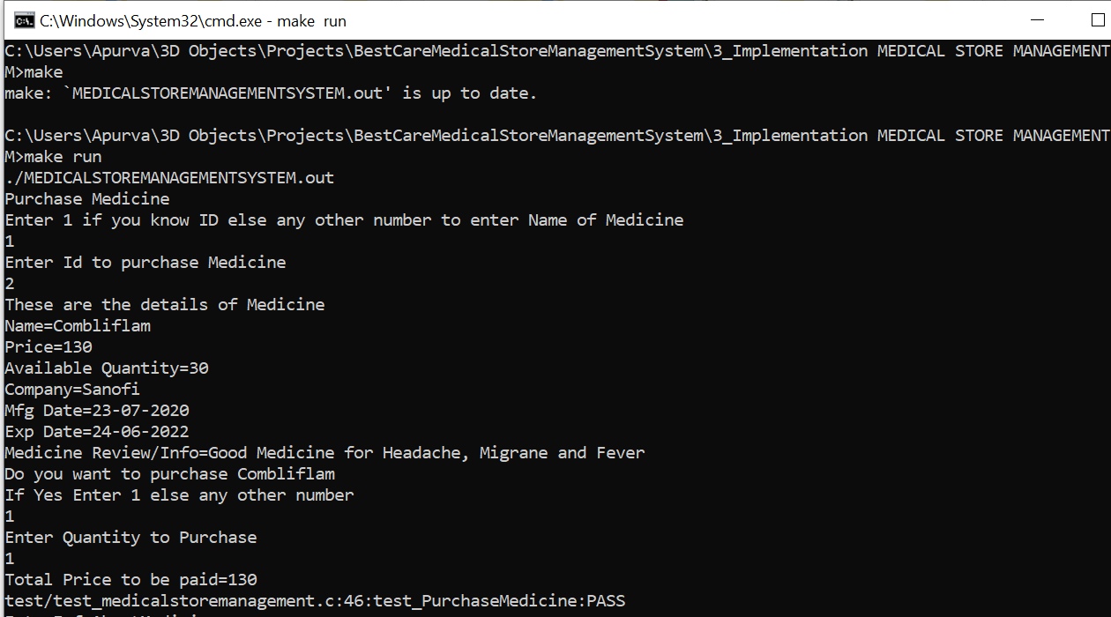

1. Test Result for Test Case 2

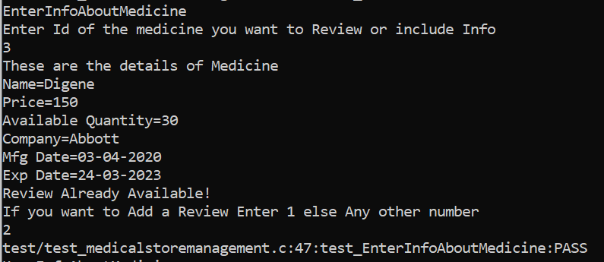

1. Test Result for Test Case 3

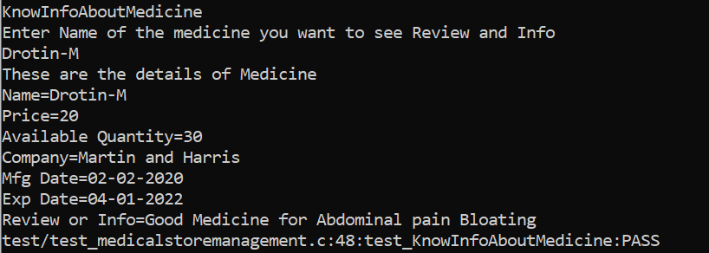

1. Test Result for Test Case 4

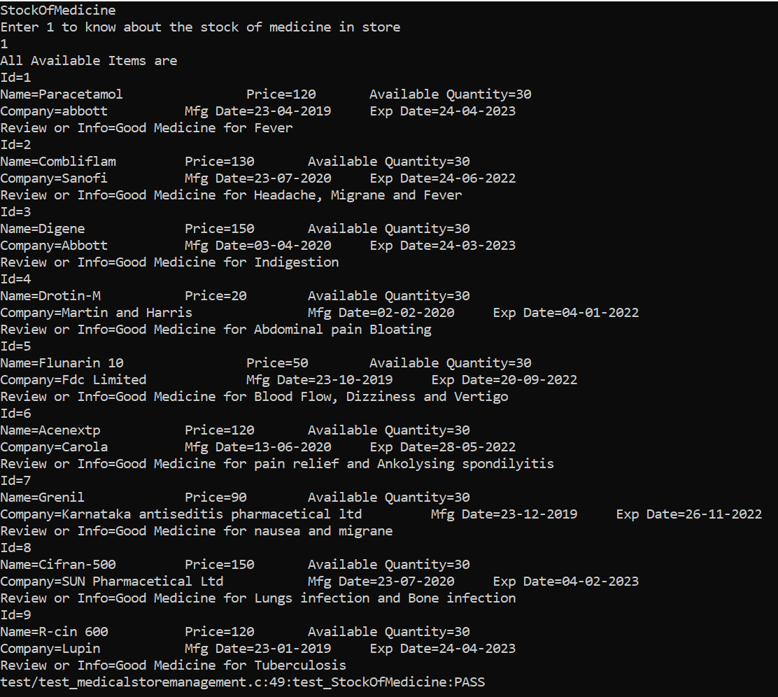

1. Test Result for Test case 5

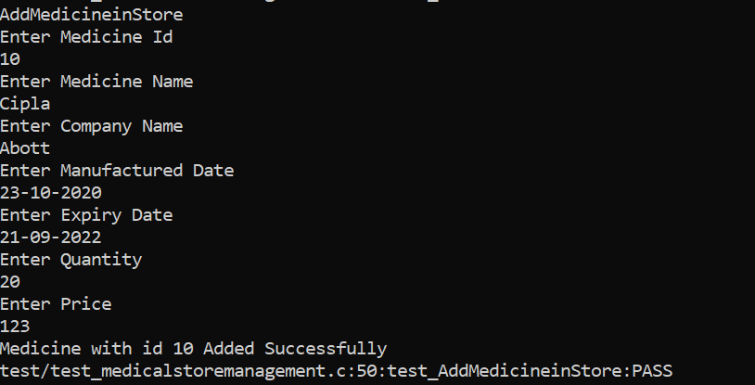

1. Test Result for Test Case 6

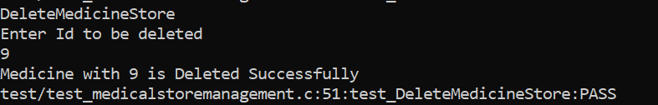

1. Test Result for Test case 7

